MicroGoal
Ideation Phase
Define the Problem Statements
Date | 7 feb 2026
Team ID : | SWTID-2026-5748
Team Size : | 4
Team Leader : | HARINI A
Team Member: | DIVYA K
Team Member: | ANUSUYA P
Team Member: | INDRA R
Project Name | MicroGoal
Maximum Marks | 4 Marks

Problem Statement
Many people struggle to manage and track their daily and long-term goals because existing systems are either not secure, too complicated, or do not provide proper authentication and data privacy. Users need a simple and secure backend system where they can store, update, and retrieve their goals easily.
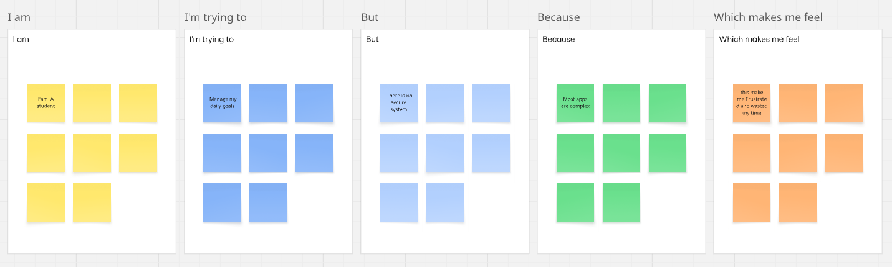

PS ID | I am (Customer) | I'm trying to | But | Because | Which makes me feel
PS-1 | A student | Manage my daily goals online | There is no simple secure system | Most apps are complex or unsafe | Frustrated
PS-2 | A working professional | Track and update my personal goals | Existing systems do not protect my data | Authentication is missing or weak | Insecure
PS-3 | A beginner developer | Build a goal management backend | Implementing authentication is difficult | JWT and middleware setup is complex | Confused
PS-4 | A user | Access my goals anytime | Some systems are not structured properly | Poor backend architecture | Unsatisfied

